**SHARJEEL WAKEEL**

H

#4/A dho

ke abdul latif kamalabad Rwp

03151236401

sharjeelwakeel837@gmail.com

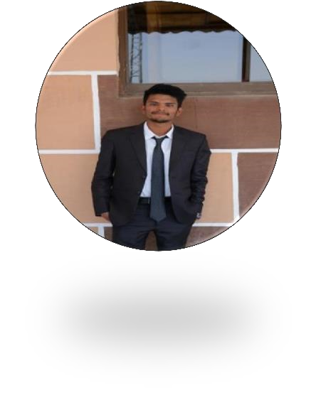

# OBJECTIVE

Looking for a challenging role in a reputable organization to utilize my technical, database, and management skills for the growth of the organization as well as to enhance my knowledge about new and emerging trends in the IT sector.

# EDUCATION

|  |  |
| --- | --- |
| Bachelor’s Computer science (in processing) | PMAS ARID AGRICULTURAL UNIVERSITY RAWALPINDI |
| intermediate | F.G LIAQUAT ALI DEGREE COLLAGE RAWALPINDI |
| Matriculation | F.G BOYS HIGH SCHOOL NO.1 RAWALPINDI |

# SKILLS

* HTML
* CSS
* BOOTSTRAP
* JAVASCRIPT
* JQUERY
* PREPROCESSOR SASS
* PHP
* LARAVEL

**WORK EXPERIENCE**

* Internship in weblify

# PERSONAL INFORMATION

|  |  |
| --- | --- |
| Father Name | Muhammad Wakeel |
| Date of Birth | 12/10/1999 |
| CNIC No | 37405-9692221-3 |
| Gender | Male |
| Nationality | Pakistani |
| Religion | Islam |